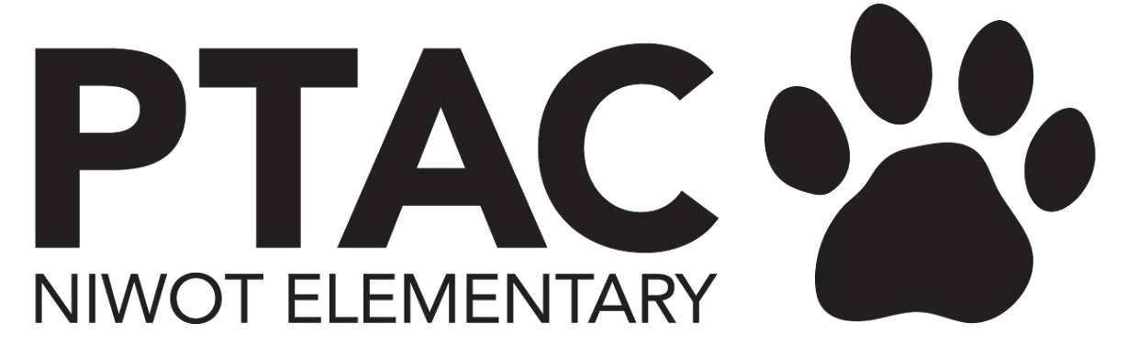
PTAC Board Meeting Agenda
July 2023

President
ITEMS TO BE DISCUSSED
- Calendar of Events for 2023-24 School Year
  - August
    - 8/15 - Meet the teacher/drop supplies -
      - PTAC table, committee reps where possible - Watchdogs, talent show, carnival
      - PTAC help recruit older kids to escort families to classrooms
    - 1st 2 weeks of school - Back to school nights
      - Script for PTAC to speak to parents
      - Sign up sheets
      - Sign ups by committee
      - Molly - ask Nancy about table
    - Later August - Get to know you coffee
      - Possibly coordinate with Movement Friday
  - September
    - Cougar Campaign - start 9/11, after labor day
      - Assets - banners, thermometer, etc
      - Easy QR codes for donations
      - Talking points about funding paras
    - New family play date - at Niwot Park
      - PTAC linens, sign up sheets, snacks - gf, df, diet restrictive inclusive, drinks
    - Movie Night 9/8 or 15
      - Need screen reservation - Paul Stone
      - Difficulty in years past due to weather
      - Molly has back up screen, but no sound system
      - RIGHTS to MOVIE - HOW TO OBTAIN??
    - Dining for Dollars 9/20
      - $2-3K/year
      - Chipotle - always a big donation, set up dates to offset Mwebaza club event
    - WatchDogs
      - Volunteer night - pizza vs. donuts
      - Parent who volunteered last year there to give a short presentation about the program and their experience
      - For communication about event - brainstorm the language to be inclusive of any parent of caregiver
      - ORDER KIT - calendar, stickers & pencils - Maggie to place order
      - Nancy has stockpile of shirts
  - October
    - Niwot Trot - 10/1
      - Website - Sarah can help make adjustments to streamline the payment interface. People had issues last year adding multiple participants to cart. Also sponsor registration streamlining
      - Create QR code for easy day of event registration
      - Internet connection at the event?
      - Ensure all sponsors get logo on T-shirt or whatever visibility they are supposed to have
      - Molly - solicit Farrow
      - Billy Edwards - can he be involved, possible announcer?
      - Yoga Studio - to lead a group stretch prior to race, Monet working on that
      - Need event day volunteers
    - Sunset presentation
      - Needs good communication to 5th grade parents
  - Later Dates
    - Carnival
      - Book inside school through the district so back up plan in in place
      - Book bouncy houses early
    - Talent Show
      - Book HS auditorium through district

- Review Committees and Chairs (and gaps)
  - Need to recruit for Carnival and Year Book
    - Yearbook - maybe 2 people - photographer and designer
  - Dining for dollars - Molly has a lead on someone to help out
- Housekeeping: need to get email boxes set up for Molly, Monet & Carly
  - Sarah working on this, transfer of PWs

Vice President
ITEMS TO BE DISCUSSED
- Update on Niwot Trot

Treasurer
ITEMS TO BE DISCUSSED
- Open banking items?
  - Bank of the West - same signers for account as last year, so no need to to update signatory rights
- Finalize 2023/2024 budget

UPDATES
- Final 2022/2023 financials and cash reserves
- $59K Surplus, $10K Reserved
- This year budget $5500 for Carnival
- Maggie will circulate and post final budget

VP Fundraising
ITEMS TO BE DISCUSSED
UPDATES
- First D4$ event will be at Chipotle on 9/20
- Look for a Co-Chair for Carey Fine for Dining for Dollars
  - Molly has a potential person for this

Secretary
ITEMS TO BE DISCUSSED
- Teacher grants from surplus funds

UPDATES
- Per Maggie - teachers will get gift card at beginning of the year
- Mini grants - we have about $5K
- SquareSkate has it’s own line in the budget for this year, so will not come out of this.
- Colleen to update the mini grant application, get approval, set up emails to encourage teachers to apply

Communications
ITEMS TO BE DISCUSSED
- Accessing admin account - change verification email
- PTAC Info Flyer - what should we include?
  - What we fund, events we put on, need for volunteers, community
- Cleaning house in Facebook group - remove old/graduated families?
  - Working on a prompt to clean up group
  - We had a breech this summer where someone not in the school got in and post something non-school related
- Membership Toolkit - update teacher lists? Remove old/graduated families?
  - Encourage teachers to talk about this at Back to school night
  - Ask teachers to copy and paste a blurb about this in all communication
  - Blurb for Nancy’s emails
  - QR code to the site that PTAC could have at supply drop off, Back to school nights, etc, send code home in folders?
  - Would really help teachers out with handling requests for info
- Need a Yearbook Editor (possibly 2?) for next year.

UPDATES
- Will work with Maggie to purchase Canva subscription

Volunteer Coordinator
- Emily will lead this again

Meetings - ideally dates set early - may help encourage more parents to attend, as well as teachers.

Encourage teachers to attend PTAC meetings if they are applying for a grant

Goal - increase school community participation as much as possible!

Next Meeting
8/14 - Week school starts

